Appendix B

WIN-RAND: The System C-Rand under MS-Windows

Introduction

Win-Rand, Version 1.0 of September 1995, is the first implementation of C-Rand working under the platform MS-Windows. Our development started with the compiler Borland C++ 3.1, but later it was adapted to Borland C++ 4.5 using OWL 1 directory structure. Hence, for recompilation it is necessary to copy this OWL1 structure into Borland C++ directory\source. Win-Rand 1.0 runs on any PC where Windows 3.1 or higher is installed. The contents of the program corresponds to C-Rand 2.1 of July 1994 as described in the manual. In the following we concentrate only on the features of the new user interface.

Getting Started
The enclosed floppy disk contains the compressed file w_rand.exe and the file install. txt.

Installation of the program on hard disk

If you want to install your program on hard disk, please follow the instructions 1. to 9.
- Copy (by using the file manager of windows, any other file tools or the DOS copy commands) the file w_rand.exe into the root directory or any other directory of your hard disk, where you want to have the files of winrand (e.g. c: \).
- Execute w_rand.exe from the directory. This activates decompressing of w_rand.exe into the following structure of directories and files under the directory winrand:
winrand contains the manual of the user interface of winrand, winrand.doc (in MS Winword 6.0 format), the file win_rand.exe the corresponding windows help file winrand.hlp, the file ctl3d.dll and win_rand.dsw, and the following directories:
winrand\owl1: Files and directories for recompilation under Borland C++ 4.5
winrand\file_demo: Source files of win_rand.exe and winrand.hlp
winrand\gen_con: Source code of generators of continuous distributions
winrand\gen_dis: Source code of the generators of discrete distribution
winrand\gen_uni: Source code of the generator of the uniform distribution
winrand\man_tex: Tex files of the manual of C_Rand 2.1
- Delete the file w_rand.exe. Check whether the file ctl3d.dll is in the system directory of your windows directory. If this is not the case, please copy it from your directory winrand into the system directory.
- Move to the program manager of windows and click the group, in which Win_Rand should be admitted.
- Select the item New... from popup-menu File. A window is appearing called new program object.

- Mark the entry program and press the OK-Button. Another window called file attributes is loaded.
- In the line specification type Win_Rand. The complete path-name of the file (e.g. c: \winrand\win_rand.exe) must be written in the command-line.
- The installation is finished by pressing the OK-Button. A symbol named Win_Rand appears in the group as selected in 2.
- Start the program by doubleclicking the symbol.

User Interface

Once Win-Rand is started the following Window (called MainWindow of the program) is created:

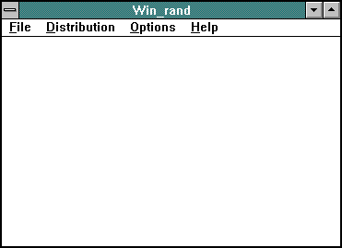

The 4 items of the menu are:
1. File
2. Distribution
3. Options
4. Help

1. File

The menu File contains only the entry Exit. It is just to quit the program.

2. Distribution
Selecting the distribution
Here you have the choice between more than thirty discrete or continuous distributions. In most cases this activates automatically the dialog window of the attached generator. For distributions where at least two generators are offered you can select your favourite sampling routine (e.g. binomial distribution, choose one of the generators btpe, bruec or bprsc).

Selecting a Generator
After selecting a generator (here biomial generator bprsc) the following dialog appears:

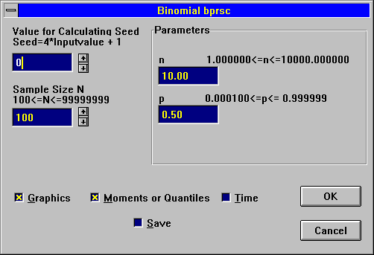

Now you can select the starting value of Seed, the input value of Sample Size and the values of the Parameters. You can also choose the output configuration by marking the corresponding checkboxes (Graphics, Moments or Quantiles, Time and Save). Your settings are accepted by activating the OK-Button.

For discrete distributions an additional dialog appears in which the suggested number of classes for histograms may be changed.

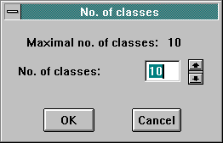

The calculation begins once the input values have been fixed, and output is created according the configuration defined before. Note that different sets of random numbers may be generated simultanously; the only exception is during the calculation of timings (see below). If Graphics has been marked too, then the following small window appears.

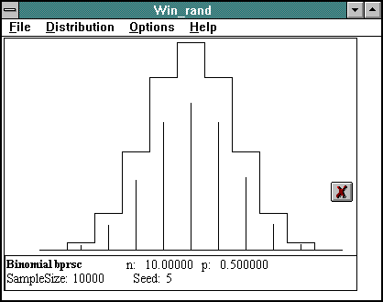

The theoretical curve is plotted and one can observe the generation process of the empirical values as growing sticks. After completion the graphics is represented in colors that have been set in the menu Colors (see 3. Options).
If the choice has been restricted to the items Moments (or Quantiles) and Save then the small window includes a bar carrying the percentage of the task already completed. The selection of Time shuts down the mouse during calculations to make the timing as precise as possible.(If you want to compare the timings of two generators, be sure that your system runs under the same conditions for both cases).
On the right side of the small window there are the following 6 or (in case of SVGA Graphics) 7 buttons: . With those buttons (i) one can determine the kind of display on the small window, (ii) one can calculate output values that haven’t been calculated before, (iii) one can delete the small window or create an enlarged window in which all informations are visualized together. These informations can also be printed. The buttons are selfexplanatory:
View or calculate graphics
View or calculate moments (or quantiles)
View or calculate noncritical regions (only in case of SVGA Graphis)
Calculate time
Save the output on file
Open large window containing all information
Delete small window (if the corresponding large window is open, it will be deleted too!)

In the large window (as shown below) there is the menu Output where you can determine the items from which you demand an output. You can also activate the printing process of informations appearing within the window.
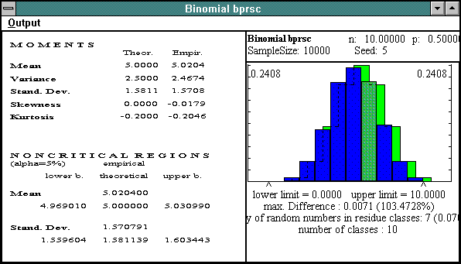
Four small windows can be visualized simultanously on the screen. The number of small windows which may be created altogether is limited to 100.
If there are at least five small windows one can scroll by using the scrollbar, the arrow, page down, page up, home and end keys.
Arrow down/up scrolls by one small window; page down/up scrolls by two small windows; home brings you to the first small window, end to the last one.
The following display shows several outputs (activated by the corresponding buttons) of generators from four different distributions: biomial bprsc (Graphis, ), beta bbbc (Moments, ), Burr VIII (Noncritical Region, ) and normal nal (Graphis, ).

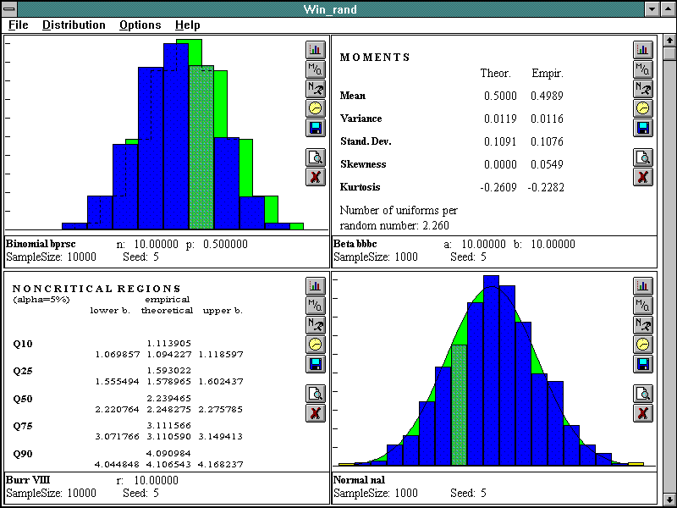

3. Options

The menu Options allows for the following useful settings: Colors, Default Settings and Printer Setup. By selecting Colors a submenu appears which carries the items Empirical Bars, Theoretical Curve, max. Difference and Residue classes. Your definite choice of an item activates the window Color in which the possible palette of both Basic Colors and Custom Colors is displayed.

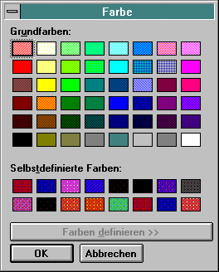
The selection of the item Default Settings yields a dialog in which you are able to confirm or change the default values of the input parameters Seed and Sample Size. You can also determine your own standard items for the output by marking at least one of the four boxes Graphics, Moments or Quantiles, Time and Save. Save enables to store the sampled values on a file having ASCII format.
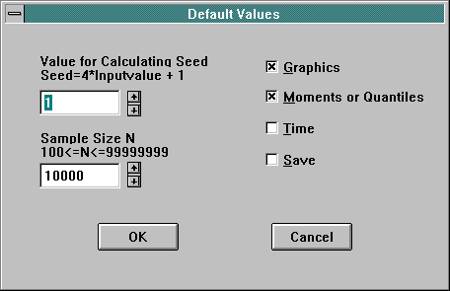
Colors and Default Settings are saved in the file winrand.ini and may be changed at will by using any text editor. After selecting the item Printer Setup you can determine the printer device.

4. Menu Help

In the menu Help the following items are available: Contents, About Calculation, Generators, How to use Win_Rand and About. Activating Contents leads to an Index containing some keywords you can look for. The item About Calculation gives you information about calculation under the key words Graphics, Moments, Quantiles. Generators yields a list of all generators implemented. There you can find short descriptions of the methods and references of the underlying papers using the standard help tool of Windows (see the example of binomial generator bprsc below). How to use Win_Rand gives a list of 8 keywords. Clicking About activates a window containing information on the actual version of Win-Rand.

Binomial bprsc
Binomial Distribution - Patchwork Rejection/Inversion

For I=min(n*p,n*(1-p))<10 Inversion method bmdu is applied: The random numbers are generated via modal down-up search, starting at the mode m. The cumulative probabilities are avoided by using the technique of chop-down. For min(n*p,n*(1-p))>=10 Patchwork Rejection method bprs is employed: The area below the histogram function f(x) is rearranged in its boy by certain point reflections. Within a large center interval variates are sampled efficiently by rejection from uniform hats. Rectangular immediate acceptance regions speed up the generation. The remaining tails are covered by exponential functions. The basic algorithms are valid for n*p > 0, n>=1, p<= 0.5. For p>0.5, p is replaced by 1-p and K is replaced by n-K.
FUNCTION: - bprsc samples a random number from the Binomial distribution with parameters n and p. It is valid for n* min(p,1-p) > 0.
REFERENCE: - C.D. Kemp (1986): A modal method for generating binomial variables, Commun. Statistics, Theory & Methods 15, 805-813 - H. Zechner (1994): Efficient sampling from continuous and discrete unimodal distributions, Doctoral Dissertation, 156 pp. Technical University Graz, Austria.
SUBPROGRAMS: - fc(k) ... Correction term of the Stirling approximation for log(k!) (series in 1/k or table values for small k) with long int k, - flogfak(k) ... log(k!) with long integer k, - drand(seed) ... (0,1)-Uniform generator with unsigned long integer *seed. - bmdu(seed,n,p) ... Binomial generator for l<10, - bprs(seed,n,p) ... Binomial generator for l>=10, with unsigned long integer *seed, long integer n, double p.
Implemented by H. Zechner, January 1994, Revised by F. Niederl, July 1994!!

